FRONT-END PROGRAMMING CSM3103



UNIVERSITI MALAYSIA TERENGGANU

LAB MODULE 5

NAME : ILHAM HANINA MADIHA BINTI OTHMAN

MATRIC NO : S63762

PROGRAMME: BACHELOR OF COMPUTER SCIENCE (MOBILE COMPUTING)

LECTURER : DR RABIEI B MAMAT

GITHUB LINK : <https://github.com/ilhamhanina/Code-Lab-CSM3103-S63762.git>

Task 1

Output for task 1:-

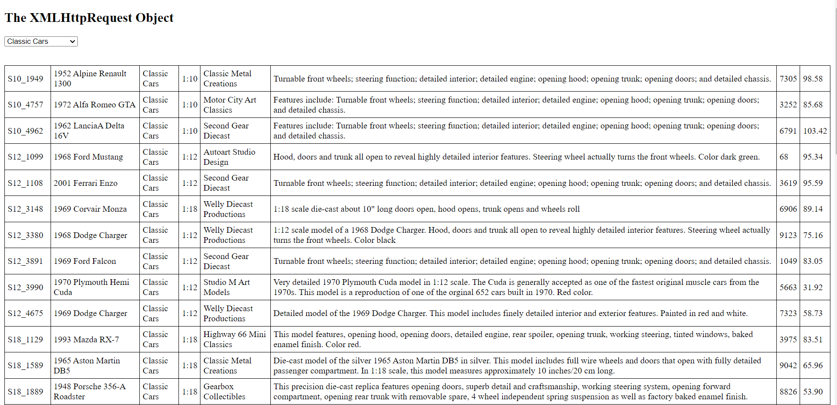

Codes:-

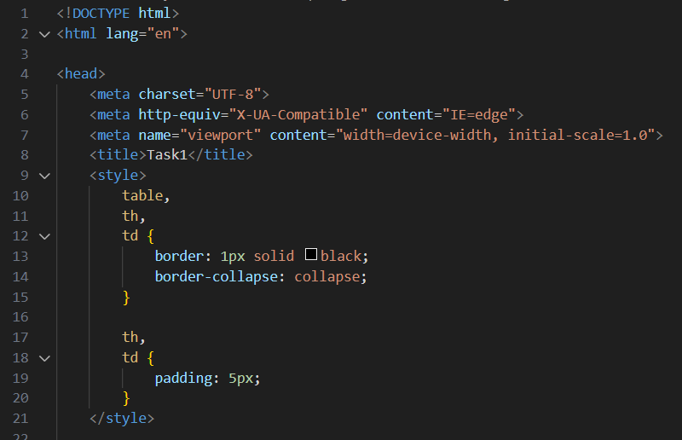

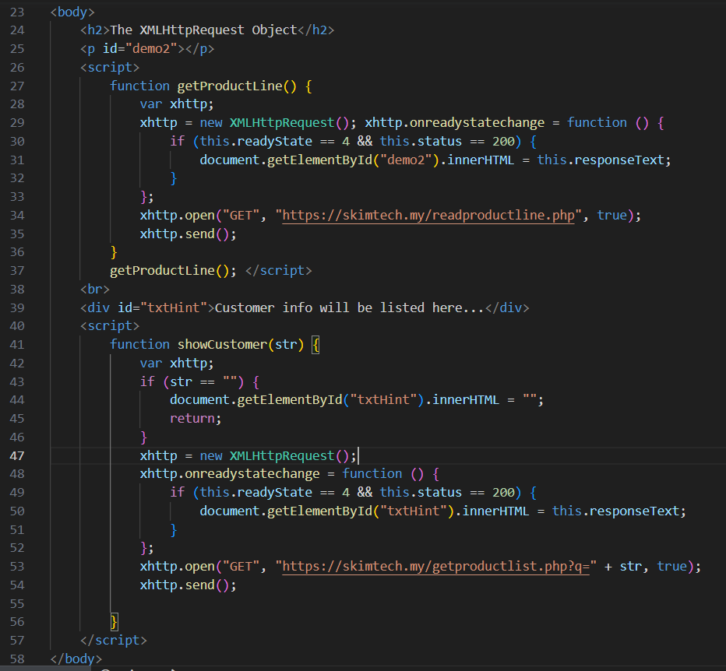



Evaluate the given file, and answer the questions:

1. What is the name of first php file?

-The name of the first PHP file is readproductline.php.

2. What is the name of second php file?

- The name of the second PHP file is getproductlist.php.

3. Recognised the item in the select option.

- The code recognizes each item in the select options as a product line. It retrieves the product lines from the productlines table in the database and generates <option> tags with the product line values.

4. What is returned by the second php file.

- The second PHP file returns a table containing product information based on the selected product line. It retrieves the products from the database that match the selected product line and generates <tr> and <td> tags to display the product details within the table.

5. Can you examine how both file is called from html file?

-In the HTML file, the first PHP file (readproductline.php) is called through an AJAX request using the XMLHttpRequest object. The function getProductline() is defined and invoked in the <script> section, which sends an asynchronous GET request to the readproductline.php file and displays the response in the <p> element with the id demo2

Task 2

Output for task2:-

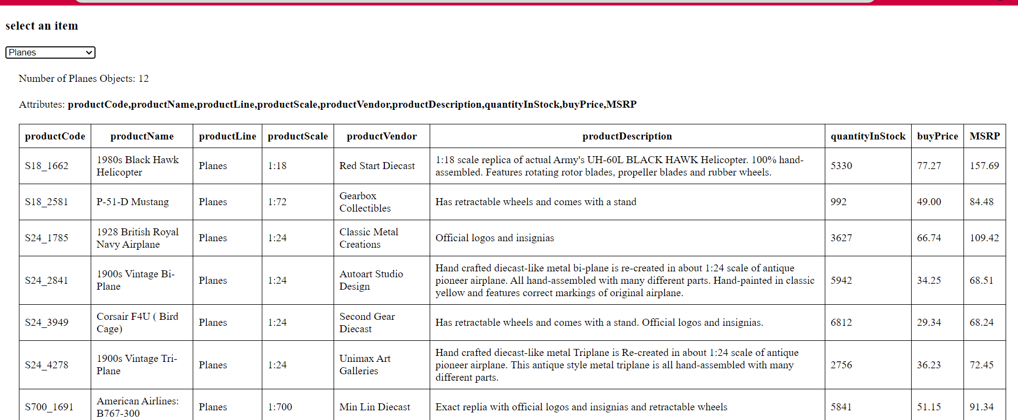

Codes for task 2:-

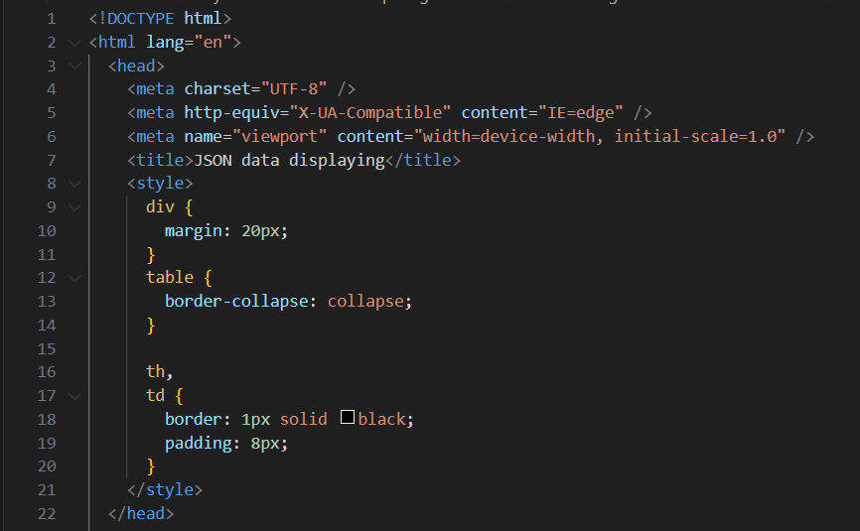

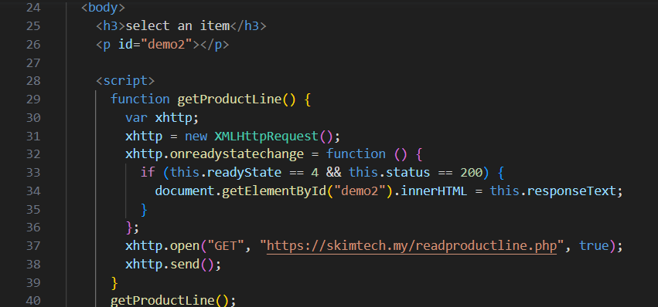

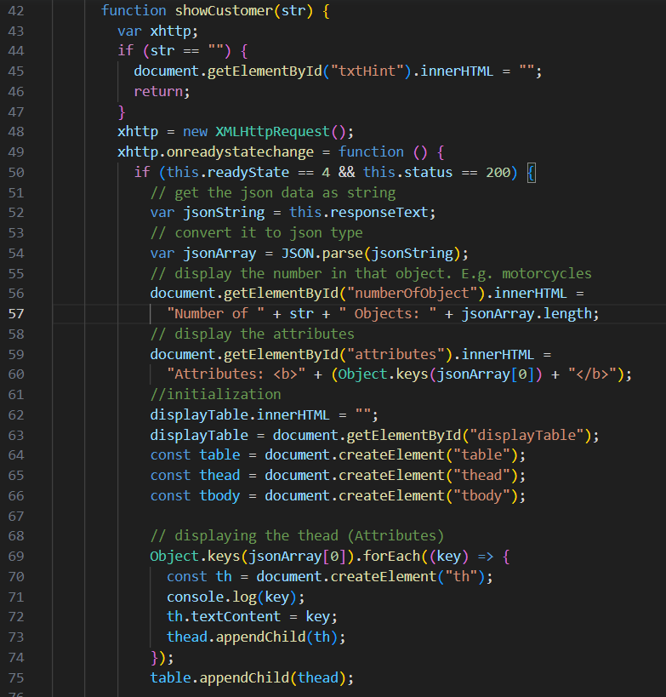

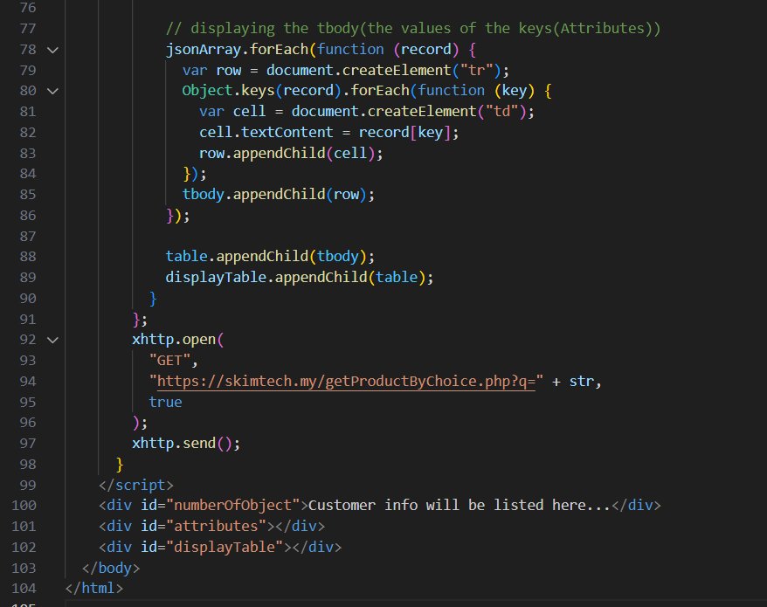

Link GitHub for the lab : <https://github.com/ilhamhanina/Code-Lab-CSM3103-S63762.git>